Screenshot:

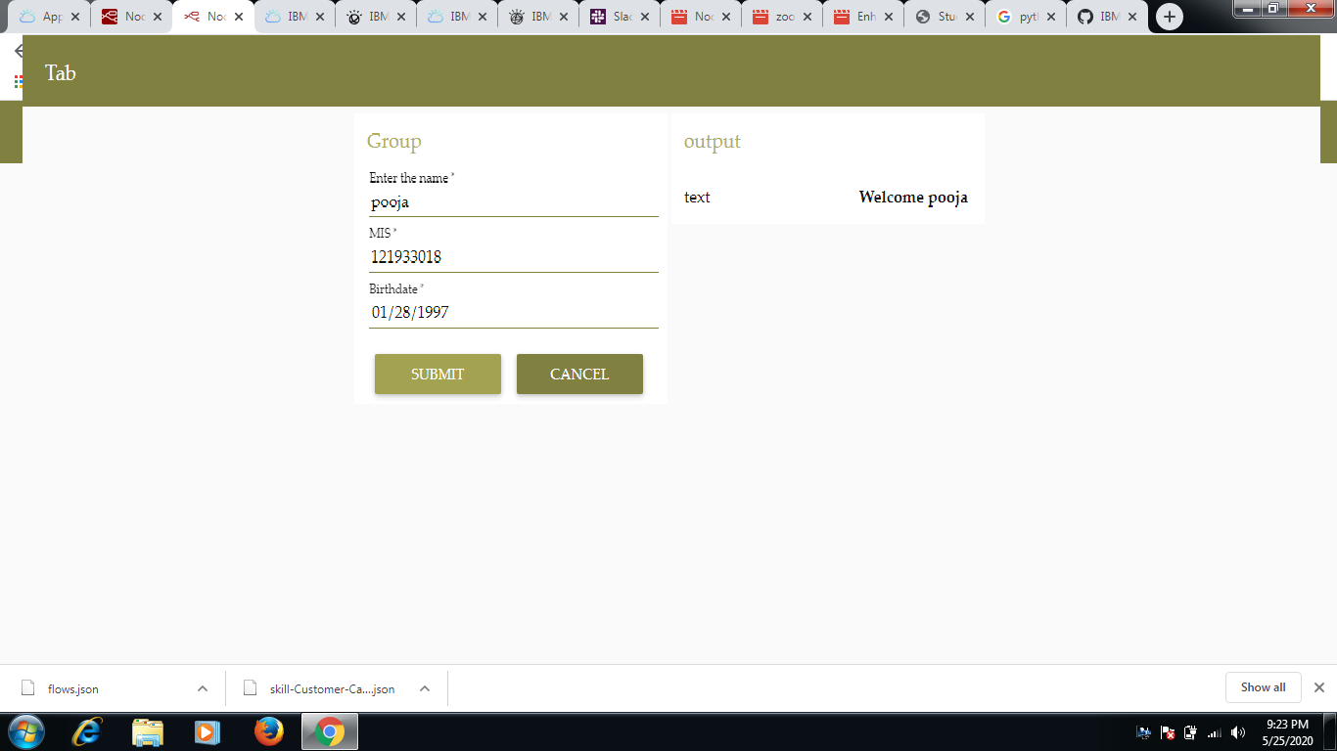

Link: <https://node-red-utqma.eu-gb.mybluemix.net/ui/#!/0?socketid=Rb5y4RXi1LJEQJlwAAAe>